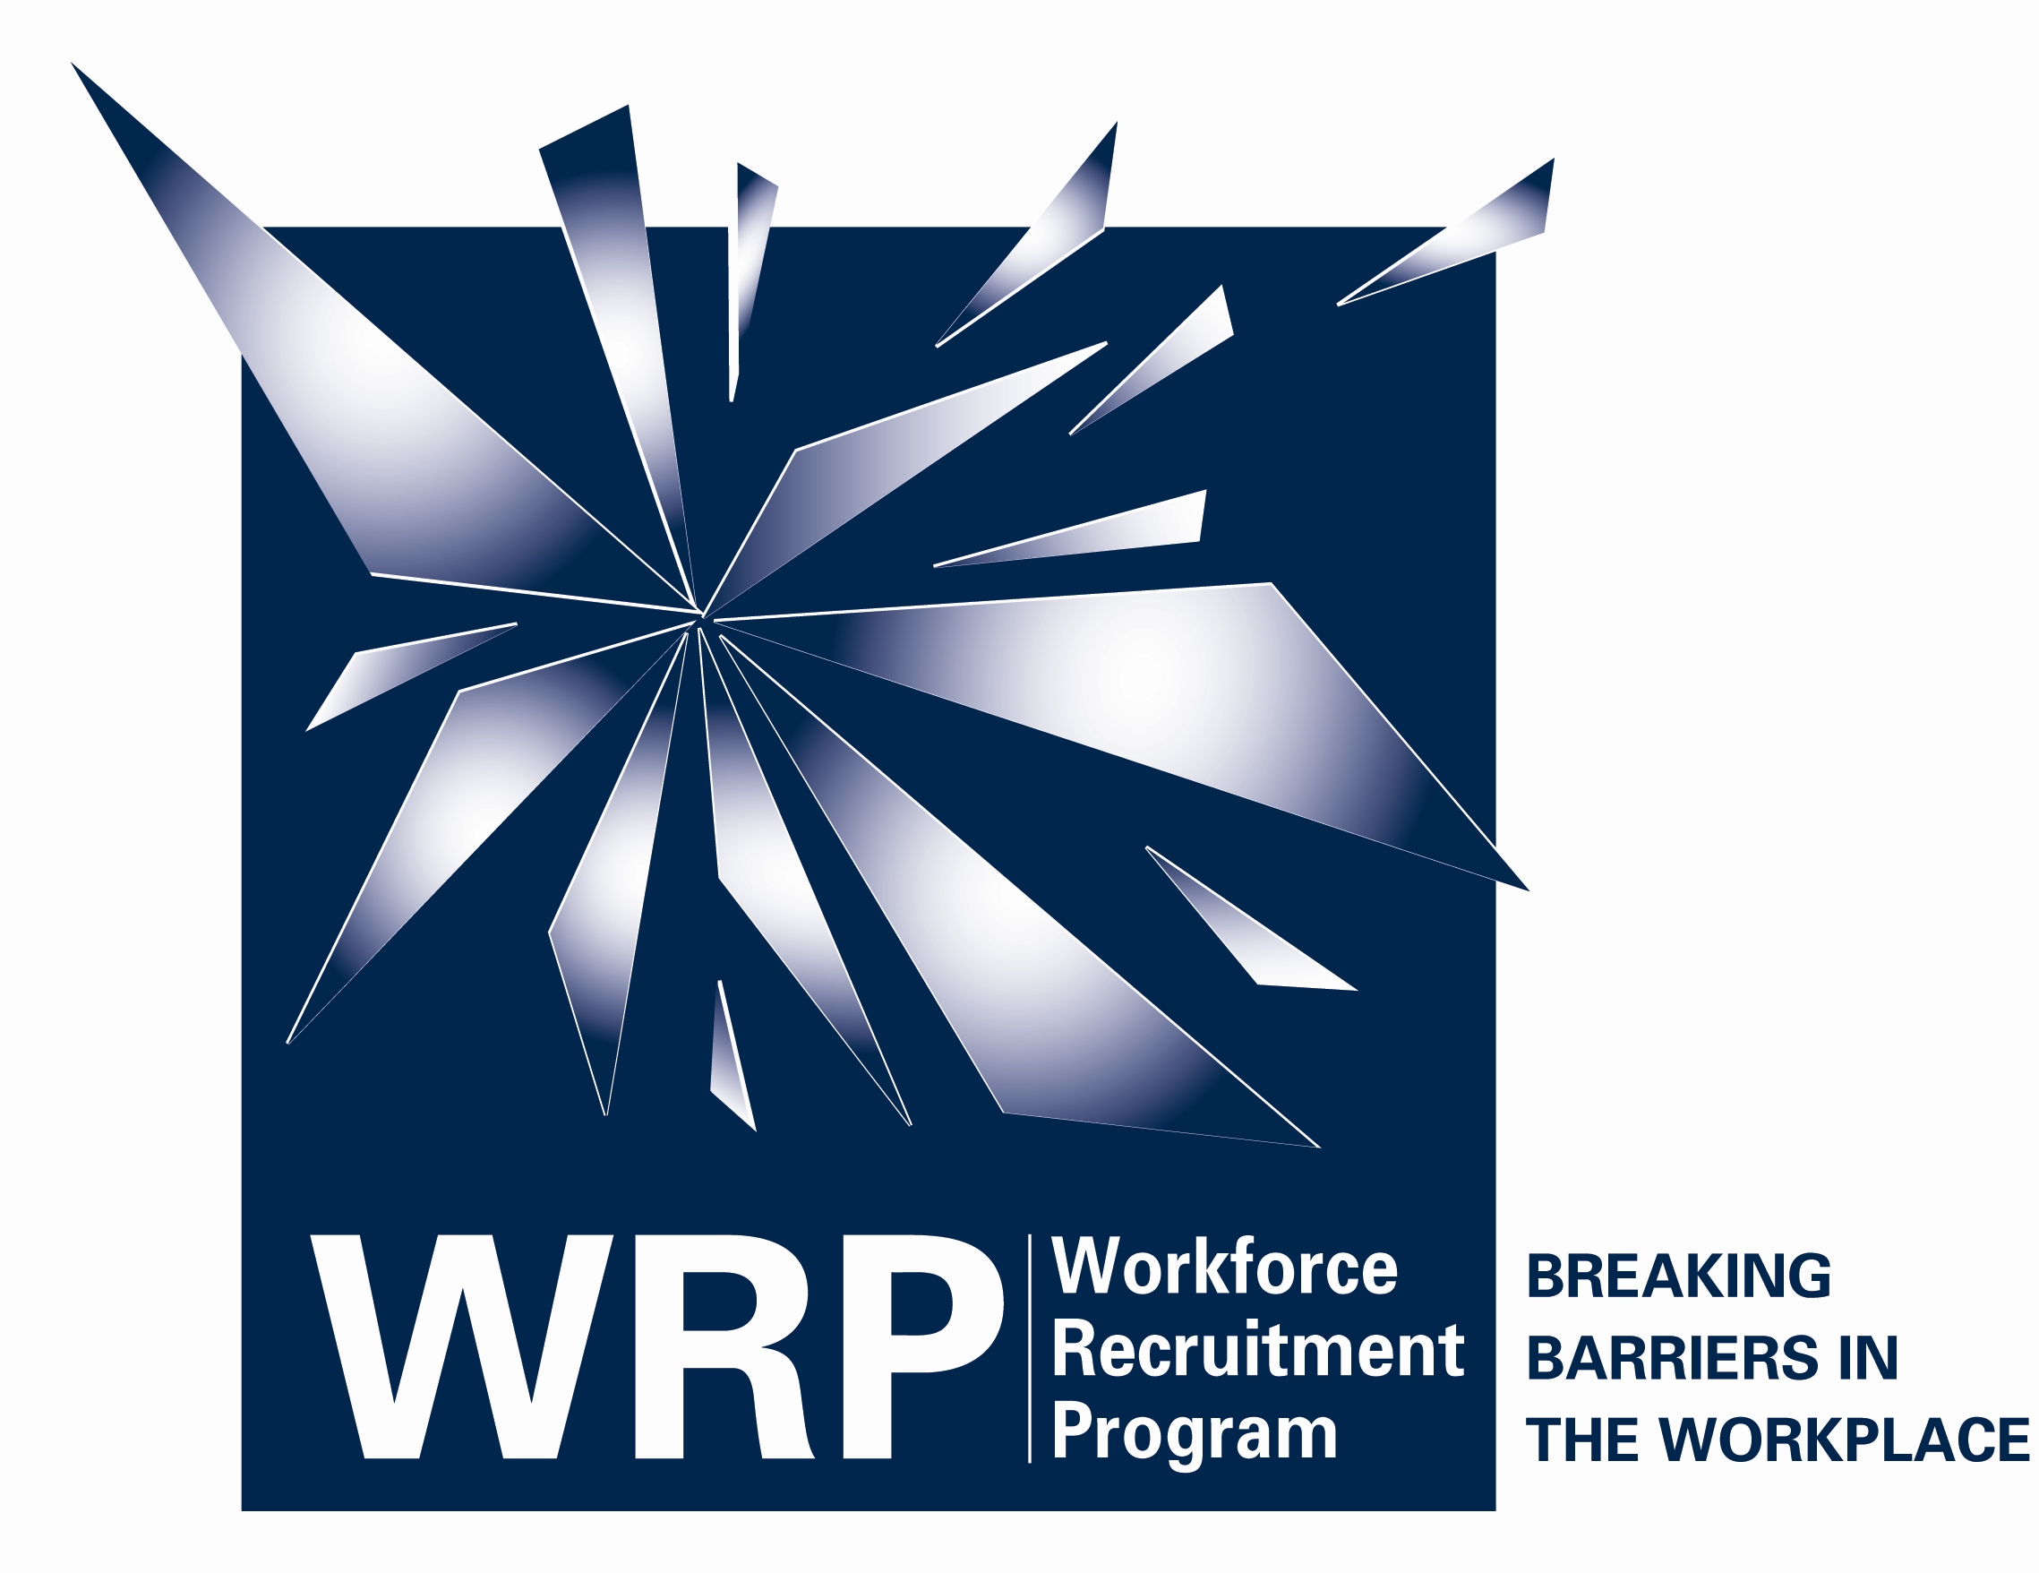
The Workforce Recruitment Program for College Students with Disabilities

The Workforce Recruitment Program for College Students with Disabilities (WRP) is a recruitment and referral program that connects public and private sector employers nationwide with highly motivated postsecondary students and recent graduates with disabilities who are eager to prove their abilities in the workplace through summer or permanent jobs.
The WRP provides students with disabilities in all fields of study the opportunity to market their abilities to a wide variety of potential employers across the United States, sharpen their interviewing skills during a required one-on-one meeting with a WRP recruiter, and gain valuable skills, experience, and contacts on the job.
Applicants for the program must:
- have a disability AND
- be a U.S. citizen AND
- be enrolled in an accredited institution of higher education on a substantially full-time basis (unless the severity of the disability precludes the student from taking a substantially full-time load) to seek a degree OR
- be enrolled in such an institution as a degree-seeking student taking less than a substantially full-time load in the enrollment period immediately prior to graduation OR
- have graduated from such an institution within the past year.
The WRP is run on an annual basis and requires student applicants to have an interview with one of our recruiters during an on-campus recruitment visit. The interviews take place during January and February of each year. The WRP is coordinated on college campuses by Disability Services or Career Services offices. Currently, nearly 200 colleges and universities participate in the program and additional campuses are added each year.
If your college or university does not participate in the WRP you may be able to interview for the program on the campus of a college that will be participating. For details send your name and the name, city and state of the college that you attend to the WRP Coordinator at WRP@dol.gov. Information will be available in late November 2009 about the recruitment schedule for 2010.

The WRP is co-sponsored by the U.S. Department of Labor’s Office of Disability Employment Policy and the U.S. Department of Defense, with support from other federal agencies.

